Computer Software
The software will be composed of a graphical user interface written in C# that will allow the user to control many aspects of their camera’s configuration. Camera configuration with be written to a config file stored on a SD card and edited as needed by changes in user preferences. Users will also be able to setup and format new compatible SD cards as needed.
Users will have the following camera options to configure through the software interface:
- Time delay between pictures
- Minimum distance between pictures
- Toggle trigger for facial detection
- Location (GPS) based halo to enable camera use
Once pictures have been synchronized to the user’s computer, they will have the option to edit, tag and remove pictures from their photo log. Tags, descriptions and comments will then be written to the pictures EXIF metadata. After making any desired changes to metadata, users will then have the option of uploading their albums to their Google account. They will then have access to ‘ReLive’ their daily experiences from any computer or device with internet access. The resulting daily albums and maps will then be available at http://www.picasaweb.google.com. Users will have an option to launch their generated maps directly from the program.
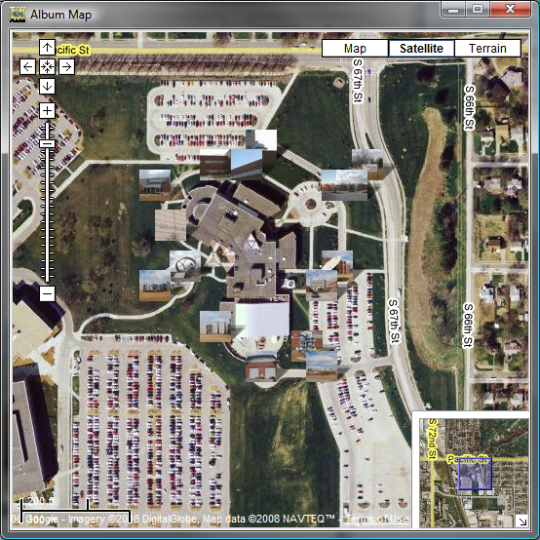
The main structure of the program is as follows:
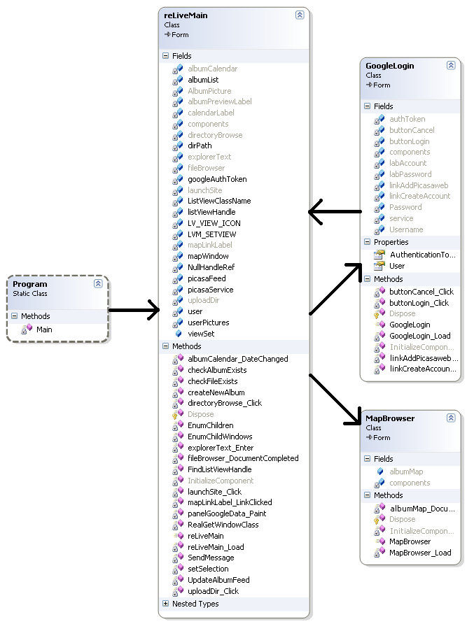

Essentially:
- Main Class – Initialization and start of graphical interface
- reLiveMain - Main graphical user interface for album management
- GoogleLogin - Graphical user interface for Google account login and registration
- MapBrowser - Graphical user interface for viewing GPS based maps of uploaded albums
- Google SDK – Contains necessary API for accessing and updating data with Google services

Early GUI Concept:
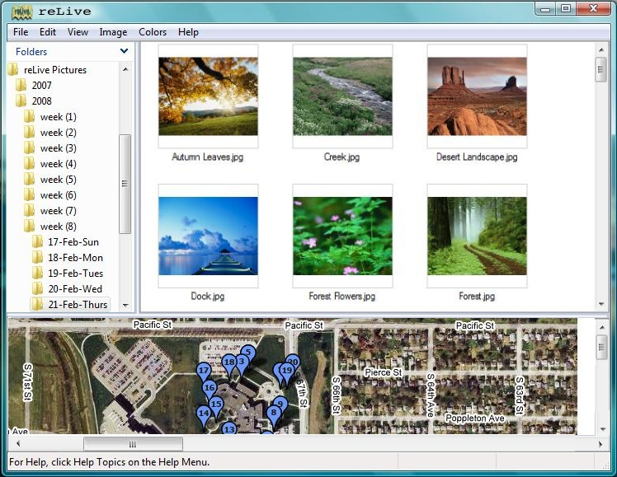
Early photoshop concept designs have guided the development of the reLive software and can already be seen in early functional design. The current build follows the concept design, but includes added functionality for accessing the users online image storage.

Current Build:
